<https://www-europe.nissan-cdn.net/content/dam/Nissan/za/brochures/FY20/X-Trail_FY20.pdf>

Engine Axle Transmission Output (kW) Torque (Nm)

2.0ℓ Petrol 2WD 6-speed MT 106 200

2.5ℓ Petrol AWD XTRONIC CVT 126 233

1.6ℓ Turbo Diesel AWD 6-speed MT 96 320

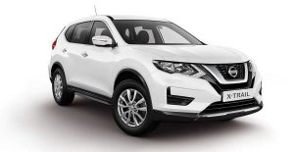

Visia 2.0ℓ Petrol 2WD 6-speed MT 106 200

* Starting price

R 453 500

EQUIPMENT INCLUDES

* Advanced Drive-Assist Display
* Chassis control - Active Ride control, Active Trace control
* Hill Start Assist (HSA)
* Signature daytime running lights
* 17” Alloy Wheels

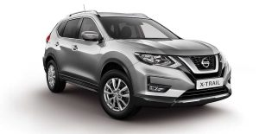

Acenta 2.5ℓ Petrol AWD XTRONIC CVT 126 233

* Starting price

R 503 700

EQUIPMENT INCLUDES

* Eco-mode driving selection
* Intelligent 4x4
* X-Tronic CVT
* Hill Start Assist And Hill Descent Control
* Chassis control - Active Ride control, Active Trace control, Active Engine brake



Acenta Tech 2.5ℓ Petrol AWD XTRONIC CVT 126 233

* Starting price

R 521 100

EQUIPMENT INCLUDES

* Navigation system with 7" touchscreen display
* Intelligent Around View Monitor with Moving Object Detection
* Intelligent Blind Spot Warning
* Intelligent 4x4
* Hill Start Assist and Hill Descent Control

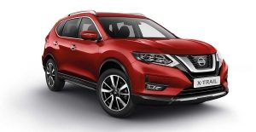

Tekna 2.5ℓ Petrol AWD XTRONIC CVT 126 233

* Starting price

R 570 000

EQUIPMENT INCLUDES

* Intelligent Around View Monitor With Moving Object Detection
* Intelligent Blind Spot warning
* Intelligent Auto Headlights
* Intelligent Lane Warning
* Intelligent 4x4
* Panoramic sunroof

# **X-TRAIL**

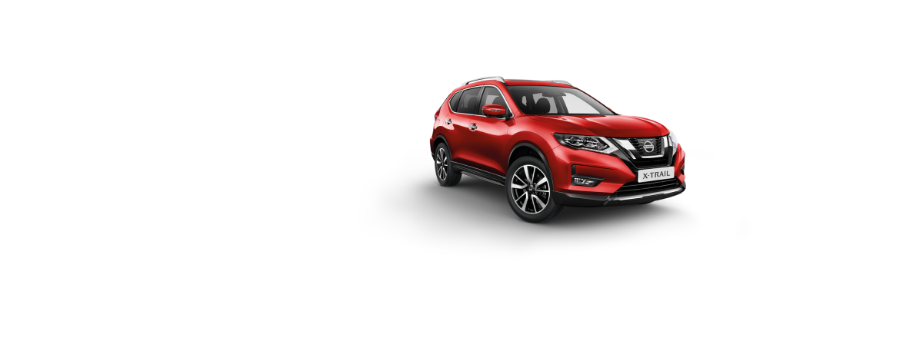

TINTED RED

# **X-TRAIL**

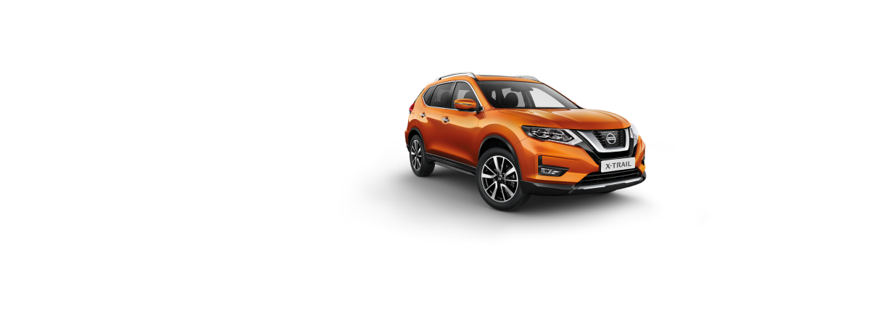

ORANGE

# **X-TRAIL**

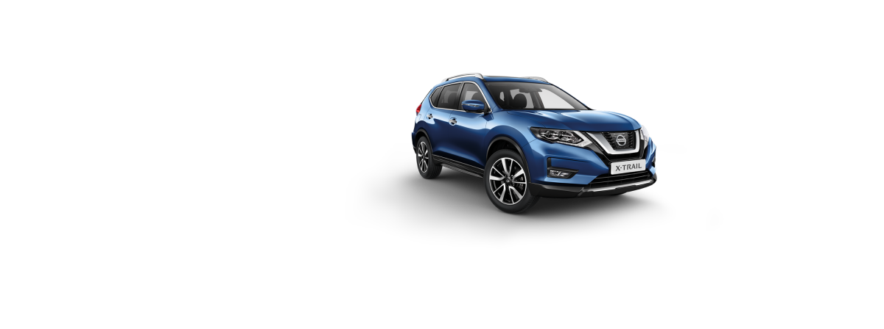

Blue

# **X-TRAIL**

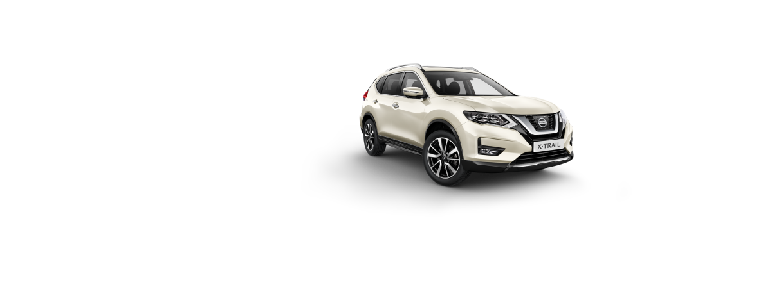

White

# **X-TRAIL**

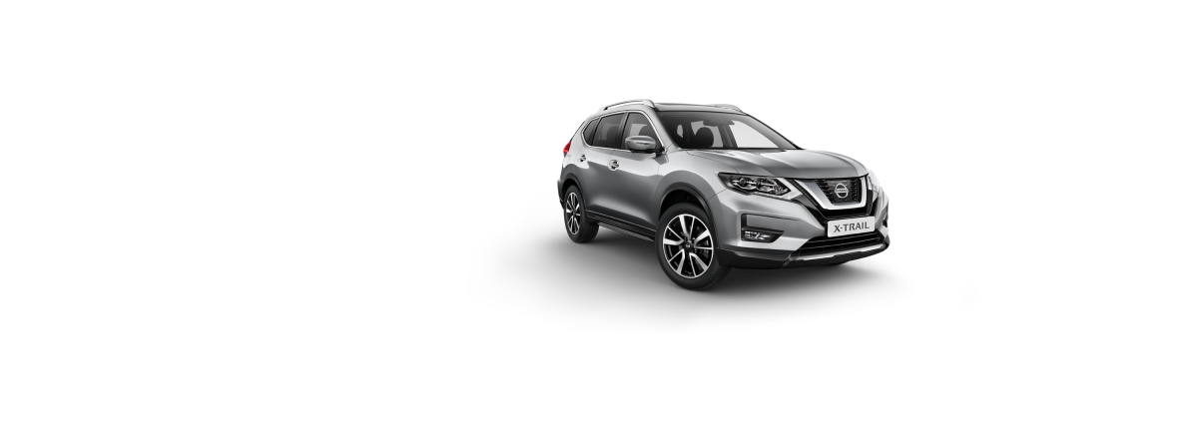

Silver

# **X-TRAIL**

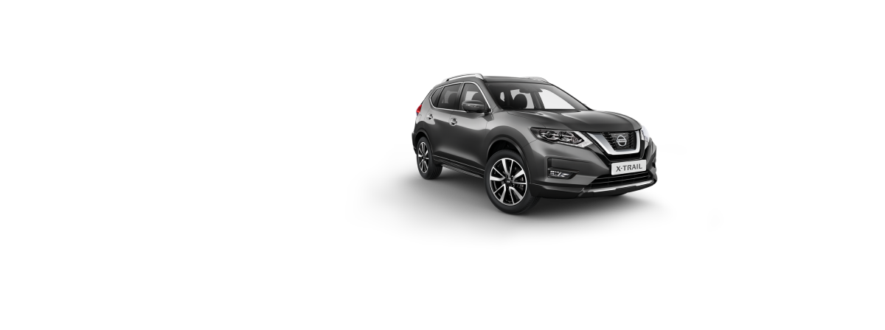

Grey

# **X-TRAIL**

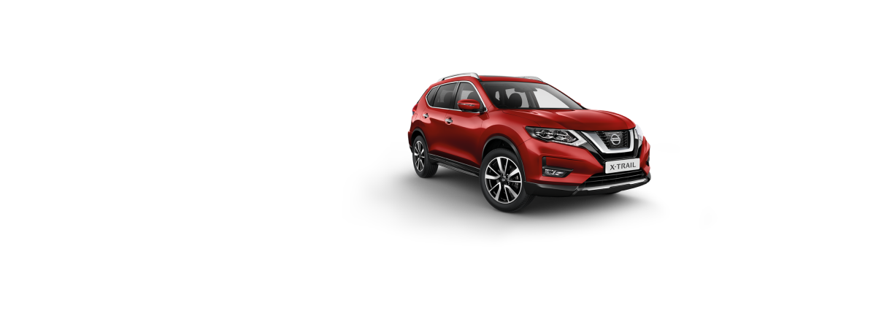

Red

# **X-TRAIL**

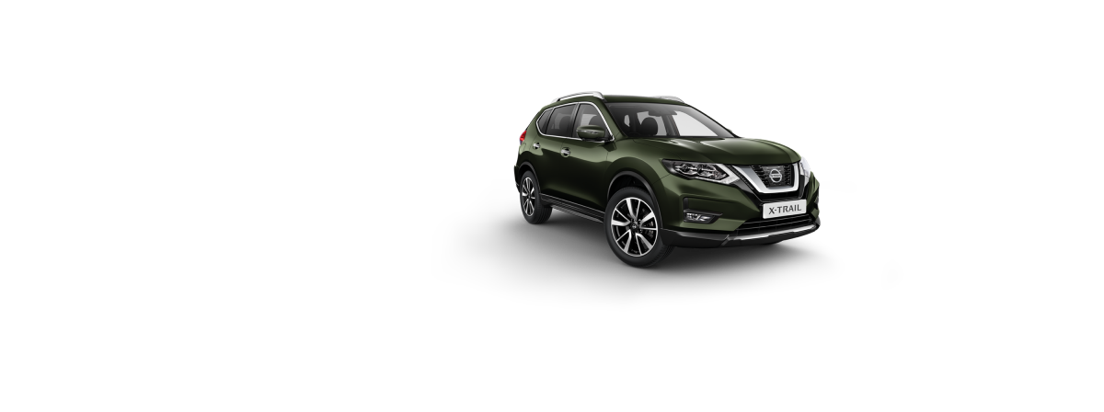

Military Green